Handout 1 – Close Reading Seminar: Prior knowledge survey

Please fill in the following form as accurately as you can. You will be able to see where you need to learn more terminology before undertaking the close-reading activity.

TERM | Definition | Effect
Mise-en-scene

Montage

Parallel action

Compression of time

Expansion of time

Turning points

Plot

Sub-plot

Three act structure

Flash back

Pull focus

TERM | Definition | Effect
White balance

Iris

Shallow focus

Wide angle

Telephoto

Master shot

Cut

Wipe

Dissolve

Jump-cut

Decoupage

Cross-cutting

Fade

TERM | Definition | Effect
Close-up

Mid-shot

Long-shot

Head room

Looking room

Extreme close-up

Diegetic sound

Non-diegetic sound

Lighting

Handout 2 – Close Reading Seminar: Terminology flash cards

NARRATIVE

Term | Definition | Effect
Mise-en-scene | Literally translated as “what’s put into the scene”, this is how the director expresses the artistic “look” or “feel” of a scene.  Properties include camera work, shot content, production design, direction of the actors and set design. | Main way of delivering narrative meaning in films.
Montage | An artistic device for creating the artistic "look" or "feel" of a scene, through the use of visual editing.  A series of shots that creates meaning by the way that they relate to each other in their order. | Emphasises dynamic relationships between shots to create ideas not present in either.
Parallel action | Cutting between two events that are taking place at the same time but in different places. | Foregrounding a turning point in the film by connecting events.
Compression of time | Where the film takes place faster in real time. | Boring bits are shortened / compressed; keeps audience involved.
Expansion of time | Where the film takes place slower than real time. | To extend exciting events.
Turning points | Key events in films where the stories move forward in a different direction. | Ensures momentum of storyline, changes outcome of  a situation, and / or character changes – grows/ becomes wiser.
Plot | The main storyline in a film, dealing with the action. | Provides a structure for the narrative / theme.
Sub-plot | The relationship plot that carries the theme. | Provides information needed to fully understand the intended meaning of the text.
Three act structure | Classic Hollywood structure with 3 main acts divided by turning points:  - exposition  - complication  - climax  followed by an ending [denouement] | The narrative is played out within a cause and effect framework. Close ending is common
Flash back | Where events from the past are interwoven into the present. | To fill in the gaps in the narrative / storyline.

Handout 3 – Close Reading Seminar: Terminology flash cards

CAMERA

Term | Definition | Effect/purpose
Pull focus | Where the focus shifts from one part of the shot to another. | To emphasise / draw attention to one element over another. To pullout information in otherwise crowded shots.
Shallow focus | Where part of the shot is out of focus. | Eye directed to meaning of the shot.
Iris | The amount of light let into the lens. | Gives mood and atmosphere to a shot through light.
Wide angle | Zoomed out gives the shot a large depth of field where foreground and background are in focus. The distance between the foreground and background seem large. | Exaggerates the distance between the foreground and background planes.
Telephoto | Zoomed in – gives shot a shallower focal depth and flattens the image. | Makes distant objects / characters appear close to the foreground.
Master shot | The shot that shows most or all of a scene. Often used at the beginning and end of scenes. | Shows the spatial relationship between the main characters, objects and setting in a scene.

Handout 4 – Close Reading Seminar: Terminology flash cards

SHOT SIZES

TERM | DEFINTION | EFFECT
Extreme close-up | Shows enlarged detail of subject or an object. | Focus on the reaction of usually a protagonist to an event.
Close-up | Contains almost, no background but focuses on the whole of an object or person’s face. | To isolate object / protagonist from its surroundings. Used to show emotion or draw attention to information.
Mid-shot | Figures in the frame are only seen from the waist up. | Provides detail while providing some contextual information.
Long-shot | Shows the full figure of the subject. | Gives an indication of the depth of distance – allowing the audience to gauge the size of the object or figure.
Wide-shot | Contains a lot of the landscape and helps establish the location and likely atmosphere of that part of the film. | Establishes location and atmosphere.
Handout 5 – Close Reading Seminar: Terminology flash cards

CAMERA MOVEMENT

Term | Definition | Effect/Purpose
Pan | Camera pivots from left to right or right to left or up and down either from object to object or following a figure or object. | Often used in conjunction with an establishing shot to suggest vastness or sweep of a scene.
Tilt | Camera is tilted upon down or on an angle. | Used to suggest a reaction to a scene or object usually involving strangeness, imbalance, tension or the unexpected.
Crane | An image depicting the subject from overhead, usually with the camera mounted on a mechanical crane. | A means of moving the camera and changes the point of view – the camera becomes the eye of the narrator.
Track | When the camera moves with the subject. | To suggest that the viewer is sharing in the movement or journey of the object or figure in the frame.
Zoom | The movement of the image according to the focal adjustments of the lens. Can enlarge or minimise the image / object. | Alters the distance of images emphasising or minimising their importance, or can add pace and bring movement to a shot.

Handout 6 – Close Reading Seminar: Terminology flash cards

CAMERA ANGLES

Term | Definition | Effect/Purpose
High | Shot taken when the camera is above and looking down on the scene or object but directly overhead. | To make the object or figure look small and lacking in power suggesting insignificance or vulnerability of the object or figure.
Low | Shot taken when the camera is below or looking up at the object or figure. | To make the object or figure look large and powerful suggesting the dominance or power of the object
Dutched | The camera is tilted on its side so that the subject appears on an angle on screen. | To create the sensation of confusion and disorientation.

Handout 7 – Close Reading Seminar: Terminology flash cards

EDITING

Term | Definition | Effect/purpose
Cut | When one shot replaces another on screen. | Adds pace and/or change in setting/ time / place.
Wipe | Where one shot ‘pushes’ another shot off screen. | Usually used to suggest a shift in place and/or time.
Dissolve | Where one shot disappears as another shot appears over the top. | Usually suggests a shift in time and/or place.
Jump-cut | Where the edits are noticeably jarring to watch. | Keeps the figures constant and changes the background or keeps the background constant and changes the figures.
Decoupage | Classic style of editing that is ‘seamless’, not intended to be noticed by the viewer. | Ensures continuity of storyline.
Cross-cutting | Cutting back and forth between two shots, such as in a conversation. | Helps understanding of meaning of conversation / action.
Fade | Where either a shot appears out of colour [fade in] or disappears into colour [fade out]. | Signifies closure of scene.

Handout 8 – Close Reading Seminar: Terminology flash cards

COMPOSITION

Term | Definition | Effect/purpose
Head room | The space above the head in shots. | Provides balance.
Looking room | The space in front of a character, dependent on the way they face. | Framing controls the distance, angle and height of vantage point of reference for viewer.
Diegetic sound | Sound that exist in the world of the film. | Adds to the reality of the scene / action etc.
Non-diegetic sound | Sound/ music added to create mood and feeling appropriate to the intended meaning of the scene. | E.g. high pitched violin music to signify danger – as in the shower scene in Psycho. Provides a major way for the plot to manipulate our grasp of story events.
Lighting | Low/high, key, backlighting, filters, ambient. | Create mood and feeling to ensure understanding of the meaning of the shot is clear.

Handout 9 – Close Reading Seminar: Telephone Whispers

Adapted from:
Effective Literacy Strategies – A guide for teachers
Learning Media, Ministry of Education.

Telephone Whispers

The students work in groups of four. One student writes a definition for a given term, and then the other student, who has not seen the original term writes a term that fits the definition.

Purpose of the strategy

This strategy gives the students the opportunity to recall, then write, their own definition of a term and to see how well their definition conveys the intended word to another student. It gives teachers the opportunity to assess their students understanding of key terms.

What the teacher does:

- Prepare four charts, see below, in the first column of each chart write a different list of key terms.

- Give each member of the group a copy of the four charts. After writing their definitions in the second column, each student folds the paper between the first and second columns and passes the page onto the next student.

- The next student fills in the third term column, folds the page again and passes it to the next student until all columns have been completed.

- When the four pages are opened up, the students can check whether the words and definitions are similar and discuss any anomalies.
Telephone Whispers chart
TERMS | DEFINTION | TERM | DEFINTION | TERM
Key term e.g.
Jump cut
Key term
Key term

Handout 10 – Close Reading Seminar: Mix and Match exercise

The teacher makes a copy of the following terms – cut - divide the class into two’s or three’s - give each group one sheet of terms to place in the correct order.

The purpose is re-testing their understanding of terms commonly used in the close reading of film texts. The students could also have to explain the effect or purpose commonly associated with the term - for example, a low angle shot of a person gives a sense of power or strength to that subject.

NARRATIVE Terminology mix and match cards

Term | Definition
Mise-en-scene | The main storyline in a film, dealing with the action.
Montage | Where the film takes place faster in real time.
Parallel action | Where the film takes place slower than real time.
Compression of time | A series of shots that creates meaning by the way that they relate to each other in their order.
Expansion of time | Literally translated as “what’s put into the scene”, this is how the director expresses the artistic “look” or “feel” of a scene.  Properties include camera work, shot content, production design, direction of the actors and set design.
Turning points | Cutting between two events that are taking place at the same time but in different places.
Plot | Key events in films where the stories move forward in a different direction.
Sub-plot | Classic Hollywood structure with 3 main acts divided by turning points:  - exposition  - complication  - climax  followed by an ending (denouncement).
Three act structure | The relationship plot that carries the theme.
Flash back | Where events from the past are interwoven into the present.

Handout 11 – Close Reading Seminar: Co-operative close reading

Questioning

A cooperative close reading square
To help students understand how films are constructed.

Purpose

Students practice verbal / oral delivery.

The cooperative reading square strategy helps students to work together and to assess and value the contribution of others as they engage with the text in a four-step process

Step 1. Questioning - monitoring understanding

Step 2. Identifying key terms and ideas - interacting with the text

Step 3. Summarising purpose and effect of term - recording

Step 4. Presenting ideas orally - communicating

What the teacher does

Select a text. This could be a short film, an advertisement, or a sequence from a feature film. It should be reasonably short and at a close reading level that matches the student’s ability.

Divide the students into groups of four and give each group a copy of the text to “read”. Explain the four tasks and associated subtasks. Each group member is responsible for one of the tasks.

Go through the four tasks (questioning, identifying key terms and ideas, summarising, and presenting ideas orally) with the whole class. The communication skills of the oral presentation can also be peer compared.

After the group activity, use the examples from different groups to discuss such questions as:

- ‘What film techniques helped you to understand the film?’
- ‘What film techniques did your group select and why?’
- ‘What did your group decide was the main idea?’
- ‘How is the tone / mood created within the text?’
Handout 12 – Close Reading Seminar:
Prompts to elicit student response

Example:
The student says “The director uses a close-up here to show the boy’s emotions…”

Teacher response:

- What is that emotion?

- Why is he showing that?

- How does the selection of the close-up work to do this?

- How does it relate to the previous emotional state?

- How is it relevant to the scene?

- How does this shot relate to the one before/after it?

- How does this effect work with other visual/aural elements?

- How is this feature used in other parts of the scene? Is it for the same purpose?
Handout 13 – Close Reading Seminar:
O Tamaiti: Opening scene model answer

You need to comment on:
Reason for selection.
- Briefly describe the scene.
- How does it fit into the film as a whole?
- Why did it appeal to you?

I have chosen this short film as it provides a haunting insight into the experiences of children in an adult world, it tells a story of loss through the eyes of an eleven year old.

The film tracks 11 year Tino, the eldest of five children from a Samoan family, in his role as guardian and protector to his younger siblings.

I have chosen the opening sequence to close read as it establishes the harsh reality of the burden of responsibility shouldered by Tino with the arrival of yet another new baby, bringing Tino’s bearing of adult responsibilities into sharper focus.

The fact that that the film was shot in black and white appealed as it takes the viewer much closer to the subject, closer to the truth of the children’s experience without the distraction of colour.

Genre / atmosphere.

What is the tone?

Mood of the scene?

How is it created?

The weight of Tino’s role as caregiver is captured through the use of; sound, mis-en-scene and Point of View (POV) shots. The POV shots are an important device in O Tamaiti as the camera is positioned at the eye level of a child and in doing so contributes to creating a child like perspective of the world. The filmmaker to create an atmosphere of unfriendliness and a lack of empathy for Tino in the adult world uses sound. This feeling is shaped by the echoing of Tino’s footsteps, the loud banging of doors, the use of silence interspersed with the low threatening musical composition creates a sombre mood against which the narrative unfolds from Tino’s POV. The focus of the Mis-en-scene is on creating a reality of a Samoan child’s world as an immigrant family.

We are introduced into Tino’s world as the camera tracks him walking hesitantly down a silent, empty hospital corridor toward a coke dispenser. The camera cuts to an extreme high angled close-up of the machine that renders it an interesting, novel and seductive object to a new migrant. Tino places the money in the coin slot and the camera cuts to a partially shown white-coated medical staff member (who is framed from Tino’s POV) brushing past and ignoring him. The visual decapitation of the adult and the sound of the swinging doors create a threatening atmosphere.

The mood changes when the camera tracks Tino walking back to his siblings who wait obediently for his return; an extreme long shot frames the children in the hallway which emphasises their vulnerability and their lonely world which the children endure in silence. They are seen and not heard. Next a series of POV shots from Tino’s perspective are inter-cut with tight close-up shots of his siblings as he dutifully passes the drink from one sibling to the next. This allows us to meet Tino’s charges and understand his role as caregiver.

Tino and his siblings are always positioned in the foreground of shots to highlight his responsibility and the burden from a child’s POV. The tight framing of the children sitting on the hallway form shows how the children occupy their own world within the world of the adults. Tino’s display of love and patience towards his siblings and their respect for his authority highlights the reality of his role. The silence of the adult world is momentarily broken when his youngest charge cries out in hunger; Tino automatically cradles and feeds the child. The only sounds we hear are diegetic, focusing on the reality of the children’s experience.

Suddenly, ironically the silence of the children’s world is shattered by the adult world, with the piercing cries of the mother giving birth. The camera cuts from the children, to where the cries emanate, to the end of the darkened corridor, to a reaction shot from the children, to an outline of the father who appears in shadow at the hospital doors telling the children to “come and see the new baby”. The command is authoritative and impersonal. The feeling of Tino’s burden and lack of acknowledgement of his role by the adult world is carried through the film by the use of the lowered camera. This creates a parallel-opposing, separate world in which both factions dwell and one that the adult world seldom acknowledges.

You should be able to make a comment on the following headings and how they create meaning in the scene – what can we read from what we see and hear, using ‘film terminology’?

Mis-en-scene / composition.

Framing / Composition

- Camera position/ angles/ shots. A possible response: Camera position

Achievement
The dominance of the lowered camera position allows the audience to focus on the children’s experience of their world. The children are mostly shot in the foreground of shots with the adults often shown in the background. [2 examples: white coated medical staff partially shown; father appears in the shadow in the hospital doors]

Achievement with Merit
Above plus; the visual decapitation of moving adults prioritises the children’s view of their world. Serving to reinforce viewer identification with the children’s POV. [White coated medical staff member, father in shadow]
Achievement with Excellence
As above plus; the children are often shown at the foreground of many shots, this is contrasted with how the adults are shown usually in the background or out of the shot. The adult’s presence is often constructed through the sound of their voices. These techniques work to highlight the difference between an adult and child’s experience of the world. (The swinging doors; father calling the children to see the new baby.)

- Shot size / angle + camera movement.
High angle / close-ups

Achievement
Close-up shots of Tino, his siblings and objects he encounters as the coke dispenser machine. The CU shots are used to highlight the reality of Tino’s role as caregiver. Passing drink from one sibling to another, Tino at the coke dispenser machine. Extreme close-ups render common objects as interesting and alienating. [Coke dispenser; swinging hospital doors]

Achievement with Merit
As above plus; as they must be for a child of a new immigrant family as they encounter the seductions of the West (2 examples).

Achievement with Excellence
As above plus; close-up used in conjunction with high angled shots helps us to empathise with Tino’s experience of the hostile adult hospital environment. (2 examples)

- Sound

Achievement
Both diegetic and non-diegetic sound are used in this scene; Tino’s echoing footsteps, the loud banging of the doors, low menacing music (at the beginning of the scene) creates a feeling of alienation and coldness.

Achievement with Merit
As above plus - Dialogue is kept to the minimum defining the gulf between the child’s world and the adults’ world. The story is told through the mechanical actions of responsibility. (2 examples provided – silence of the children, father calling out to the children)

Achievement with Excellence
As above plus - It is the noises and voices of the adult world that often dominate. What we hear creates a major role in creating our impressions of the adults and their impact on the children in the film; we hear their noise and the effect on the children’s through POV close-up reaction shots capturing the alienating effect of the sounds. (2examples provided)

Handout 14 – Close Reading Seminar:

Student task sheet - Avondale Dogs: Pigeon shooting scene

You need to comment on:
Reason for selection.
- Briefly describe the scene.
- How does it fit into the film as a whole?
- Why did it appeal to you?

Genre / atmosphere.

What is the tone?

Mood of the scene?

How is it created?

Choose 3 ‘mood’ words (e.g. Excitement, tension, panic, etc.) and explain how the mood of the scene changes. What do we see and hear that suggests this change?
1.

2.

3.

You should be able to make a comment on the following headings and how they create meaning in the scene – what can we read from what we see and hear, using ‘film terminology’?

The first one has been done for you, showing three levels of response.

- Shot size/angle + Camera movement.

Close-ups:

A: Are used to focus the viewer on the tension on the boys’ faces (2 examples: Paul takes a sneaky look at his dad washing the car before firing the gun. Paul looks panicked and shrinks into the foliage after killing the pigeon.)

M: The close up tightens through the sequence to heighten the panic ([illustrated with examples.)

E: They contrast with other shots in the sequence and bring our focus on the boys as the subject of the scene. Used in conjunction with shaky hand-held-like shots (shot with a long lens) the sense of us (the viewer) sneaking a look at these hidden boys also helps build the tension of their actions.

- Mis-en-scene/composition.

- Transitions + Length of takes.

- Sound.

Handout 15 – Close Reading Seminar:

Answers for Handout 14 – Student task sheet

Avondale Dogs: Pigeon shooting scene

90277 Model response for assessment task

You need to comment on:
Reason for selection.
- Briefly describe the scene.
- How does it fit into the film as a whole?
- Why did it appeal to you?

I have chosen this short film as it has a strong emotional impact in looking at the relationship of a young boy [Paul] and his mother, who is dying of cancer. The film focuses on his attempt to come to terms with this tragedy.

The ‘pigeon shooting’ sequence takes place near the beginning of the film and establishes the idea of sub-conscious guilt the Paul feels for his mother’s illness. Paul’s ‘accidental’ killing of the pigeon also suggests the helplessness he feels about events in his life. It is the first ‘death’ and foreshadows the end of the film. It also introduces Glenys, the girl that lives next door, and who will be supportive at the resolution.

Genre / atmosphere.

What is the tone?

Mood of the scene?

How is it created?

Choose 3 ‘mood’ words (e.g. Excitement, tension, panic, etc.) and explain how the mood of the scene changes. What do we see and hear that suggests this change?

The feeling of this scene starts with excitement as the boys have typical adventure by ‘borrowing’ the gun and having pot-shots at the pigeons on the neighbour’s roof. The mood of adventure and secretive behaviour is captured by the tight framing and shallow focus through the chain-link fence. The jerky camera suggests hand-held filming, as if we are witnesses to what these boys are up to. The appearance of Glynis is spotted by one of Paul’s friends and the crash zoom foreshadows the tension that is about to come.

The mood changes when Paul shoots the bird. This change is signalled by the ‘freezing’ of the moment as the sound stops and the focus pulls on the gun barrel.
After that, the feeling is one of panic. It is as if the camera shows Paul’s fear. The edits are faster and the movement more frenetic. The point of view shots from Paul are intercut with tight close-ups of his panicking face, carefully framed by jagged shapes of iron and plants, all helping to build the tension. The fact that the sound of cicadas drown out the concern of Glynis and her mum also locates the story with Paul.

At the end the absence of the father and the hose left going in the reveal shot gives a sense of foreboding for Paul: has the father found out about the pigeon? Of course, the illness of the mother is much more concerning but because it is really Paul’s story, we are concerned for him.

You should be able to make a comment on the following headings and how they create meaning in the scene – what can we read from what we see and hear, using ‘film terminology’?

The first one has been done for you, showing three levels of response.

- Shot size/angle + Camera movement.

A possible response
Close-ups:

Achievement
are used to focus the viewer on the tension on the boys’ faces [2 examples: Paul takes a sneaky look at his dad washing the car before firing the gun. Paul looks panicked and shrinks into the foliage after killing the pigeon]

Achievement with Merit
the close up tightens through the sequence to heighten the panic – [illustrated with examples]

Achievement with Excellence
they contrast with other shots in the sequence and focuses us on the boys as the subject of the scene. Used in conjunction with shaky hand-held-like shots (shot with a long lens) the sense of us (the viewer) sneaking a look at these hidden boys also helps build the tension of their actions.

- Mis-en-scene/composition.

Framing/Composition

Achievement
is carefully used to isolate figures in the shots, particularly Paul [2 examples].

Achievement with Merit
the cameraman uses natural objects to draw our eye to the subject, such as rusty iron in the shape of a cross, foliage and the out-of-focus fence.

Achievement with Excellence
The use of this framing gives the idea that the boys are hidden and doing something naughty (as we associate hiding with this idea). The shallow focus also helps draw our eye to the subject.

- Transitions + Length of takes.

Pace

Achievement
Near the end of the sequence, as the pigeon gets shot, the cuts and movement become faster to create the sense of panic.

Achievement with Merit
The editing is hard cuts and cuts between Paul, the bird and Glynis to show us that Paul is worried because his friend has found the dead bird and is about to tell her mum. The pace of edits helps convey this.

Achievement with Excellence
The editor uses jump-cuts and so it challenges our watching, making what we see less comfortable. This is appropriate to the content/mood of this moment.

- Sound.

Diegetic Sound

Achievement
There is only diegetic sound in this scene, the boys talking, the radio and cicadas. It makes it feel like summer.

Achievement with Merit
The lack of atmospheric music works well in this scene, making it seem more ‘real’. There are adjustments in volume to focus our attention on what’s going on.

Achievement with Excellence
The use of natural sounds also seem to be ‘located’ in Paul. We hear the racing commentary from his dad’s radio immediately before cutting to Paul’s POV of his dad washing the car. When he fires the gun, all sound stops, as if time has stopped for him, just before panic sets in. The cicadas become louder, deafening the cries of Glynis.

Some of the shots from this scene are shown on the Handout 16 - Avondale Dogs: Stills taken from the pigeon scene. For each of these answers, the understanding shown in the responses relates to the criteria set out in the standard (90277) itself.

Achieved
Describe, using appropriate terminology, how each example adds meaning to the scene.

Merit
Explain why these examples are effective in creating meaning.

Excellence
Analyse how these examples relate to the genre/atmosphere of the scene; or are used in combination with other techniques to shape the viewers’ emotional response; or relate to the film as a whole; or other external factors such as the style of the director.
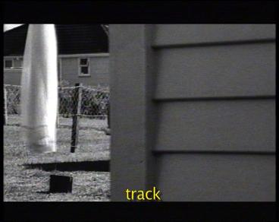
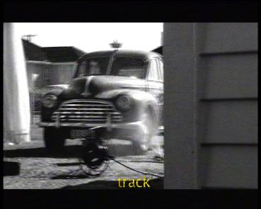
Handout 16 – Close Reading Seminar: Avondale Dogs stills taken from the pigeon-shooting scene
1.
2.

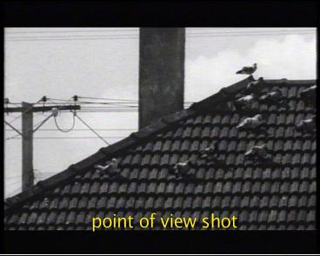
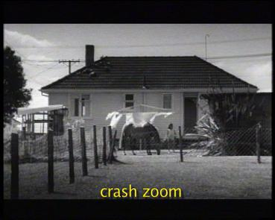
3.
4.

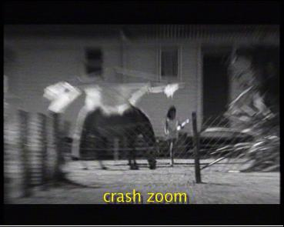
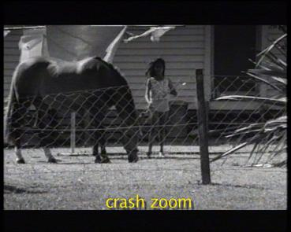
5.
6.

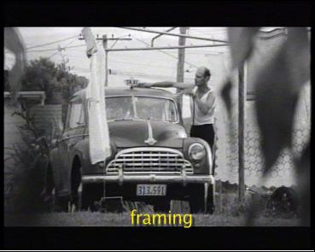
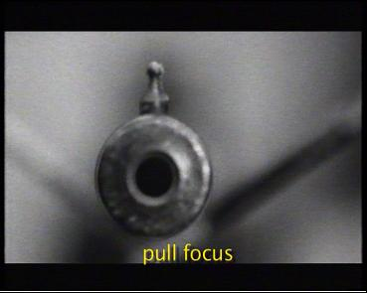
7.
8.

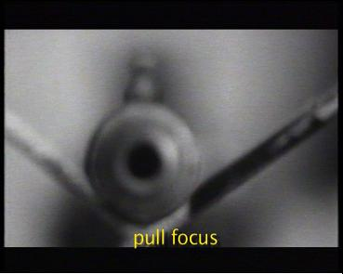
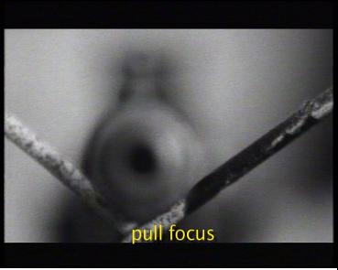
9.
10.

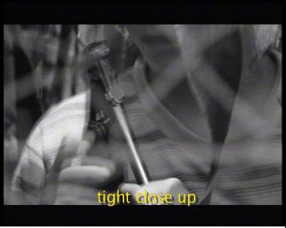
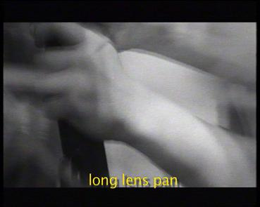
11.
12.

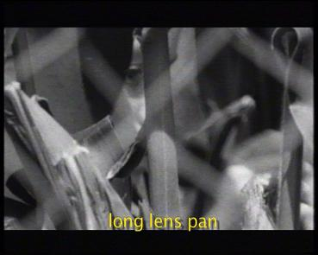
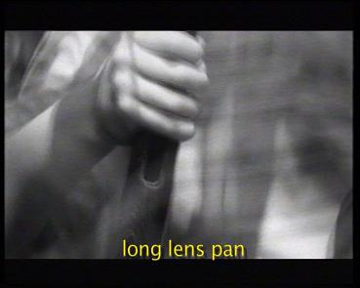
13.
14.

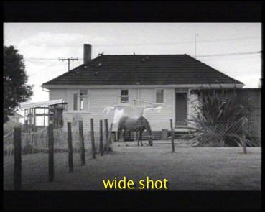
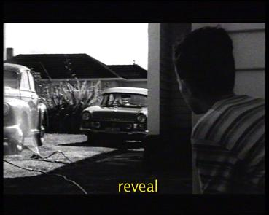
15.
16.

