Handout 17 – Close Reading Seminar: Practical assessment task

Internal Assessment

AS 90277 2.2 Close reading assessment:

Close read unfamiliar text: Scene Analysis
Media Studies Achievement Standards: Level 2
Credits: 3

Achievement | Merit | Excellence
Describe how elements of media language contribute to meaning in unfamiliar media text. | Explain how elements of media language contribute to meaning in unfamiliar media text. | Analyse how elements of media language contribute to meaning in unfamiliar media text.

1. Preparation

Choose a scene from a film that we haven’t studied in class:

You need to comment on:
- Reason for selection.

- Briefly describe the scene.
- How does it fit into the film as a whole?
- Why did it appeal to you?

Genre / atmosphere.

What is the tone?

Mood of the scene?

How is it created?

- You should be able to make a comment on the following headings and how they create meaning in the scene – what can we read from what we see and hear, using ‘film terminology’? (See example on next page.)

- Shot size/angle +Camera movement.
- Mis-en-scene/composition.
- Transitions + Length of takes.
- Sound.
- Music.
- Lighting.
- Character/Performance.
- Script/Dialogue
2. Delivery

- Bring along the tape/DVD of the film/scene. Briefly explain your choice of film and the relevance/importance of the scene.

- Screen the entire scene without comment.

- Screen a second time, pausing and commenting on at least FOUR of the categories in Question 1c.). You need to show at least TWO different examples from each of these categories, using appropriate film terminology.

“Appropriate Terminology” refers to your ability to use specific film language to describe what we see and hear. Use your language list and ask your teacher if you are not sure.

For each category:

Describe
Using appropriate terminology, what meaning each example creates – e.g. the use of low angle in the scene makes the biker look strong and threatening and acts like a POV shot from Hi.

Explain
Why these examples are effective in creating meaning. E.g. by placing the camera below the eye line and looking up, the size of the biker is emphasized and looms over us, placing us in the position of the threatened person. It makes us empathise with the ‘victim’.

Analyse
How these examples create meaning. Look at the ‘Breaking down the Standard’ sheet for a detailed explanation of what an analysis could include.
E.g. Although the use of the low angle is usually a technique to create fear, because the film is a comedy, the extreme nature of the angle, cross-cut with high angle shot of the other person, is done to create humour. The biker looks far too big and so is ludicrous, losing the threat this shot would normally create in a drama.
Assessment table: Use this to plan your seminar

Categories | Example A | Example B | Effect  Created by the use of the feature (how it creates meaning.)
e.g.: camera work -close-up
1.

2.

3.

4.

5.

Close Reading Seminar: Assessment guide

The assessment of these seminars is a holistic professional judgment with the following descriptors as a guide.

To gain Achievement
Student needs 6 of 8 of the examples are correctly identified using appropriate language, describing how these examples create/contribute to meaning. See example in activity for level of response required and Breaking down the Standard pages 12 and 13 for explanation of the words and levels of the standard.

To gain Merit
As for Achievement plus 3 explanations of why meaning is created by these examples – the effect that each element creates. See example in activity for level of response required and Breaking down the Standard pages 12 and 13 for explanation of the words and levels of the standard.

To gain Excellence
As for Merit plus 3 relevant analyses of the effect/meaning created. See example in activity for level of response required and Breaking down the Standard pages 12 and 13 for explanation of the words and levels of the standard.

Depending on the length of the clip analysed or clarity of student response, the teacher may choose to ask open questions to elicit further evidence, so that the student has the opportunity to meet a level almost attained.

Questions could include:

- Could you expand on that?

- In what way/why has the filmmaker used that technique?

- How has the director/cinematographer/editor etc. created atmosphere through light, sound, pace, etc.?

- How has the combination of techniques worked here?

- How does this scene show conventions of genre/ specific style of the filmmaker?

Close Reading Seminar:
The assessment activity process

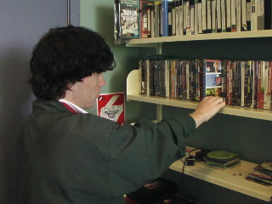
Scott: “The choosing of a film and a scene was quite hard. I needed to make sure that I could talk about lots of techniques in the scene…”

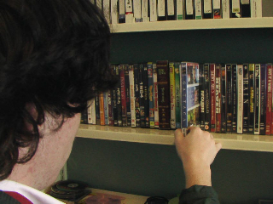
Teacher Comment: It is really important that the student makes an appropriate choice. There has to be a number of elements that are readily identifiable. As well as analysing the particular techniques, the student needs to understand what the film is trying to say and the importance of the selected scene in telling the story.
Scott: The choosing of a film and a scene was quite hard.

The scene needs to be of an appropriate length. Between two and five minutes is plenty. Generally speaking, a shortish scene allows for a more in-depth reading, as students need to focus on the details.

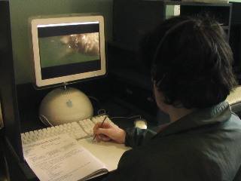
Scott: “Using the assessment sheet, I watched the scene over and over again! I made notes on why I selected the scene and how it connected to the film as a whole. I needed to explain what the genre was as well as the feel of the scene. I found examples of film techniques and worked out how they helped create meaning…”
Teacher Comment: It is really important that the student makes an appropriate choice.

Scott: Using the assessment sheet, I watched the scene over and over again!
Teacher comment: The student needs to realise that before the analysis begins, they must decide on the filmmaker’s intent in terms of genre and the atmosphere of that particular scene. The student should be able to explain the scene’s relevance and purpose in relation to the film as a whole. They may also be able to identify features that are recognisable as common to the film maker.
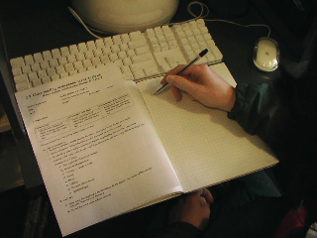
The students should use the exemplars in the activity as a guide to the level of response required.
Teacher Comment: The students should use the exemplars in the activity as a guide to the level of response required.

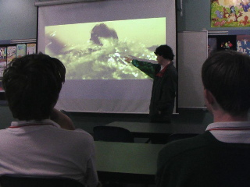
Scott: “I practiced my seminar heaps, working out how to use the remote and where to pause the DVD to discuss my key points. I made sure that I had enough examples of various features to meet the requirements of the task…”

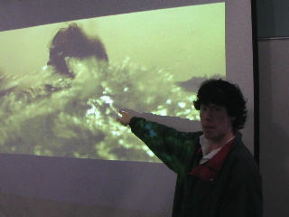
Teacher Comment: The assessment itself is not about the student’s speaking ability. The teacher must focus on the delivery of evidence that shows the student understands how meaning is created through visual and aural features. The teacher must be ready to prompt the student to either expand on what he/she has said or to look at other aspects not discussed thus far.
Scott: “I practiced my seminar heaps, working out how to use the remote and where to pause the DVD to discuss my key points.

It is handy if the seminar can be filmed so that details of evidence can be recorded for moderation purposes, and to make sure that teachers haven’t missed anything.

Teacher Comment: It is handy if the seminar can be filmed so that details of evidence can be recorded for moderation purposes.

Close Reading Seminar:
Student evaluation for end of unit

- What film / scene did you close read?

- What was your grade?

_____________________________________________________________

- Do you agree with it?

- Why did you get the grade? – (Students may use the Assessment Guide to see how they achieved the grade.)

- What parts of the seminar do you need to develop? See The assessment activity process.
No image

